5th Annual Mayfield Multiple Sclerosis 5K Run/Walk
For the National Multiple Sclerosis Society
September 9th, 2017 8:00 AM @ Kess Creek Park, Mayfield, KY
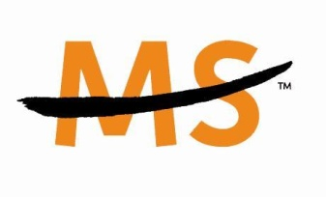
Please either register on-line at:
www.mayfieldms5k.com
Or
Please return registration plus payment to:
Mayfield MS 5K
302 Macedonia Street
Mayfield, KY 42066
Donations accepted. Get an awesome t-shirt with each $15 donation!
Questions? Please contact Dana Toon 270-519-6880 or Scott Toon 972-743-4698
Race Entry and donation Form
Form MUST be signed to participate in 5K
Name ____________________________________________________ Age (day of race) _______ Sex _______

Email______________________________________________________________________________________

Address____________________________________________________________________________________

City/State/Zip_______________________________________________________________________________

Phone_______________________________________

T-Shirt Size (circle one) S M L XL

Fee _____ $20.00 (early) _____ $25.00 (September 9) ___________ Donation Amount
*** Pre-registration is strongly encouraged, guarantees t-shirt, and saves you money
Waiver of Liability: In consideration of the acceptance of my entry, I hereby for myself, my heirs, executors and administrators do release and discharge any and all sponsors and associates of the Mayfield Multiple Sclerosis 5K Run/Walk of damages, demands or actions whatsoever in any manner arising or growing out of my participation in the event. I attest and verify that I have full knowledge of the risks involved in this event and that I am physically fit and sufficiently trained to participate.
Signature________________________________________________________________________________

